EDA projects involved in major international logistics exercise

Drawsko Pomorskie training area (Northwest of Poland) - 21 June, 2019

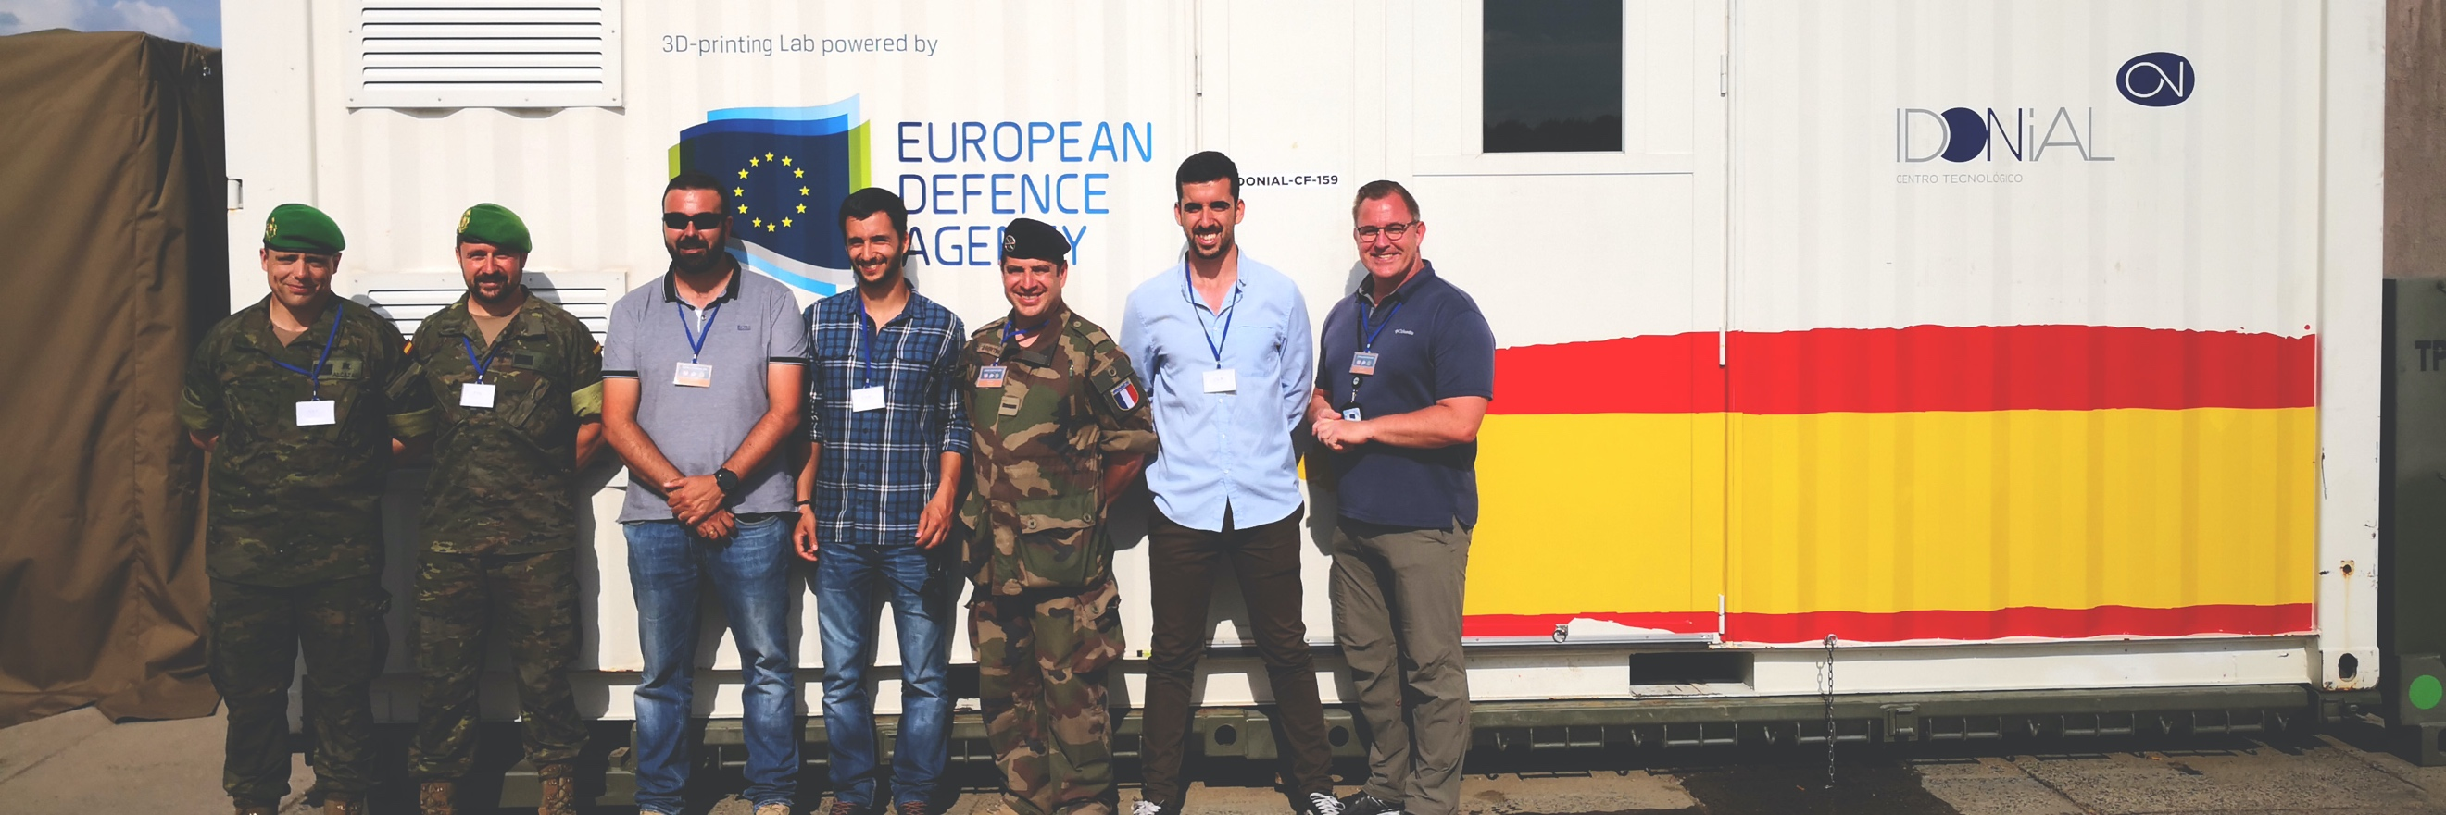

**Two EDA projects - one related to the sharing of spare parts and the other to additive manufacturing (3D-printing) - were involved in the CAPABLE LOGISTICIAN 2019 (CL19) exercise, Europe’s largest international logistics exercise, which took place at the Drawsko Pomorskie training area in the Northwest of Poland from 3-14 June. The event was organised by the Multinational Logistic Coordination Center (MLCC), a multinational sponsored centre for all issues related to multinational logistic cooperation.**  
  
Some 3,400 troops from 31 countries (including 21 EU Member States) as well as representatives from 11 international organisations participated in this event. The exercise provided participants with a rare opportunity to test and train logistic procedures within a realistic multinational operational context under real life conditions. EDA was present at the exercise with two projects:

* the **Sharing of Spare Parts project (SoSP)** launched in 2015 by 12 EDA Member States. In a nutshell, it provides a simplified request-and-response mechanism for the exchange of military services and spare parts between the participating MoDs, based on agreed standards. It offers different ways to compensate for the loan of equipment, including through a barter mechanism. Using the SoSP process is cost-free for contributing Member States. A dedicated SoSP handbook has been developed, setting common standards and processes. The reason why SoSP was brought to the CAPABLE LOGISTICIAN 2019 exercise in Poland was to test and validate its accuracy and applicability, which was done with success.  Now that it has been validated, the SoSP process handbook is considered ‘mission proven’ and ready to be used by the contributing Member States’ MoDs.
* the **Additive Manufacturing (AM)** project. AM is widely considered as a potential game-changer as it could, inter alia, help reduce the logistic footprint of military missions. In 2018, EDA commissioned a feasibility study on AM with regard to EDA R&T activities. As a follow-up step to move onward from R&T to capability development, EDA proposed to Member States to test AM during a military exercise under real-life conditions. Together with France and Spain, EDA prepared the AM test which took place during the CAPABLE LOGISTICIAN 2019 exercise. Concretely, EDA deployed an AM Demonstrator in the form of a 20 ft standard container equipped with PolyJet and Fused Deposition Modelling technologies, 3-D scanner and appropriate software. Prior to the exercise, specific spare parts for military assets used at the exercise were identified by France and Spain. All of them could be printed during the exercise. Furthermore, the exercise showed that using a 20 ft container for the printing ensures logistical flexibility in the operational support and reduces the logistic footprint of a military operation. AM is thus a useful alternative to classical warehousing in military logistic supply chains, ensuring increased availability of spare parts, considerable time and cost savings as well as operational flexibility.

During the CAPABLE LOGISTICIAN 2019 Visitors Days, EDA had the opportunity to present AM as a potential technology for military purposes and has received a lot of positive feedback. The discussions during the Visitors Days underlined the necessity of establishing a forum within EDA for subject matter experts to exchange experiences and discuss logistic processes, technology developments and legislative issues to further promote AM and support Member States in their efforts to better use the AM potential to develop a military capability, as also highlighted in the 2018 Capability Development Plan (CDP) and the subsequent Strategic Context Cases (SCCs).